A

REPORT ON

Project

On

**Python Web App**

Submitted in partial fulfilment of the requirements

for the award of the Degree of

Bachelor of Computer Applications

Of

Poornima University

Submitted By:

**Ritik Chhipa**

**Siddharth Joshi**

**Rai Bhupender**

**Ajay Thapa**

**Jatin Yadav**

II Year, BCA

Submitted To:

**Celebal Technologies**

**ACKNOWLEDGEMENT**

The success and final outcome of this project required a lot of guidance and assistance from many people and we are extremely privileged to have got this all along the completion of my project. All that we have done is only due to such supervision and assistance and we would not forget to thank them.

We respect and thank **Ms. Anuradha Raheja**, for providing me an opportunity to do the project work and giving us all support and guidance which made me complete the project duly. I am extremely thankful to her for providing such a nice support and guidance, although he had busy schedule managing the corporate affairs.

We are thankful to **Dr. Manoj Gupta, ProPresident, Poornima University** for providing us a platform to carry out this activity successfully.

We are also very grateful to **Mr. Shamneesh Sharma(HOD, BCA Department)** for his kind support and guidance.

We are thankful and fortunate enough to get constant encouragement, support and guidance from all Teaching staffs which helped us in successfully completing our project work.

Ritik Chhipa

Siddharth Joshi

Rai Bhupender

Ajay Thapa

**Abstract**

In this project, we are making a web based application to share content and record participant activity.

Nowadays, as we can see due to this COVID-19, most of the classes and coaching held online in which teacher share some content and educate students on web-based application

* In that scenario teacher does not know that student actively studying, or She/he just turn on his system and working on something else.

* To resolve that issue, we need to track student activity as well, we need to detect if student is actually studying or not.
* We need to create an app/algorithm that will continuously streaming student web cam data and detecting student activity.
* At the end of lecture, your application should how

actively student attending class.

**TABLE OF CONTENT**

Cover Page

Acknowledgment

Abstract

1. What is App Service………………………………………………

2 . Key Features of App service ……………………………………..

3 . Technologies ……………………………………………………...

4 . Step to make a Web app…………………………………………….

5. Reference

### ***Project -*** Web App

### **What Is Web App Service?**

A Web application (Web app) is an application program that is stored on a remote server and delivered over the Internet through a browser interface. Web services are Web apps by definition and many, although not all, websites contain Web apps. According to Web.AppStorm editor Jarel Remick, any website component that performs some function for the user qualifies as a Web app.  
  
Web applications can be designed for a wide variety of uses and can be used by anyone; from an organization to an individual for numerous reasons. Commonly used Web applications can include webmail, online calculators, or e-commerce shops. Some Web apps can be only accessed by a specific browser; however, most are available no matter the browser.

1. **Key features of App Service:**

* **Developer Productivity** - Since smart people are the most precious resource you have any framework or architecture we adopt needs to help optimize developer productivity time.
* **Usability** - Usability is vitally important for a number of reasons. It improves trust, customer satisfaction and reduces support costs.Any technology you use should allow you to build a world class user experience
* **Security** - Security is the capability of a system to reduce the chance of malicious or accidental actions outside of the designed usage of the system, and prevent disclosure or loss of information.
* **Relatability** -Reliability is the ability of a system to continue operating in the expected way over time. Reliability is measured as the probability that a system will not fail and that it will perform its intended function for a specified time interval.
* **Performance** - Performance is an indication of the responsiveness of a system to execute specific actions in a given time interval. It can be measured in terms of latency or throughput. Latency is the time taken to respond to any event. Throughput is the number of events that take place in a given amount of time.

1. **Technologies:**
2. **PyCharm**: PyCharm is an integrated development environment (IDE) used in computer programming, specifically for the Python language. It is developed by the Czech company JetBrains. It provides code analysis, a graphical debugger, an integrated unit tester, integration with version control systems (VCSes), and supports web development with Django as well as Data Science with Anaconda.
3. **Flask:** *Flask* is a micro web framework written in Python. It is classified as a microframework because it does not require particular tools or libraries. It has no database abstraction layer, form validation, or any other components where pre-existing third-party libraries provide common functions.
4. **OpenCV**:*OpenCV (Open Source Computer Vision Library)* is an open source computer vision and machine learning software library. *OpenCV* was built to provide a common infrastructure for computer vision applications and to accelerate the use of machine perception in commercial products. Being a BSD-licensed product, OpenCV makes it easy for businesses to utilize and modify the code.The library has more than 2500 optimized algorithms, which includes a comprehensive set of both classic and state-of-the-art computer vision and machine learning algorithms. These algorithms can be used to detect and recognize faces, identify objects, classify human actions in videos, track camera movements, track moving objects, extract 3D models of objects, produce 3D point clouds from stereo cameras, stitch images together to produce a high resolution image of an entire scene, find similar images from an image database, remove red eyes from images taken using flash, follow eye movements, recognize scenery and establish markers to overlay it with augmented reality, etc. OpenCV has more than 47 thousand people in the user community and an estimated number of downloads exceeding 18 million. The library is used extensively in companies, research groups and by governmental bodies.
5. **Time**: The **Python time module** provides many ways of representing **time** in code, such as objects, numbers, and strings. It also provides functionality other than representing **time**, like waiting during code execution and measuring the efficiency of your code.

4**. Step to make a Web app:**

1. Open PyCharm IDE and Create Project.

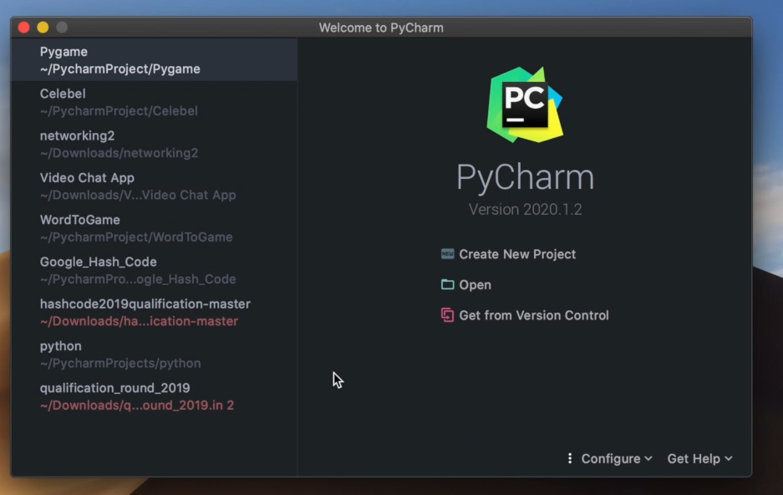

1. Import helpful module like OpenCV for Computer vision or Camera use .Flask for Web Application .IO for Input output operation perform.time and last time module for calculate time .

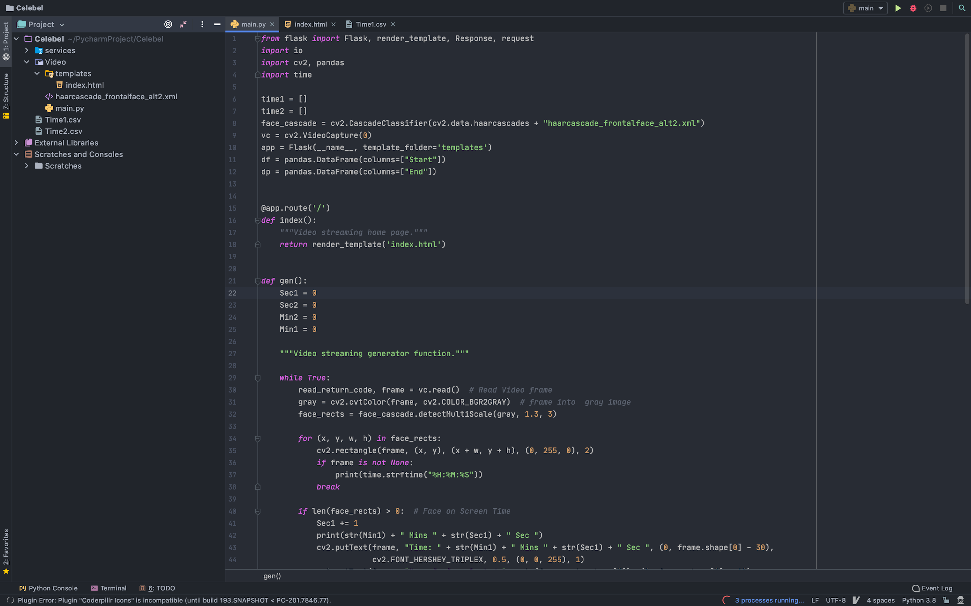

1. Create fronted Interface in Index.html file

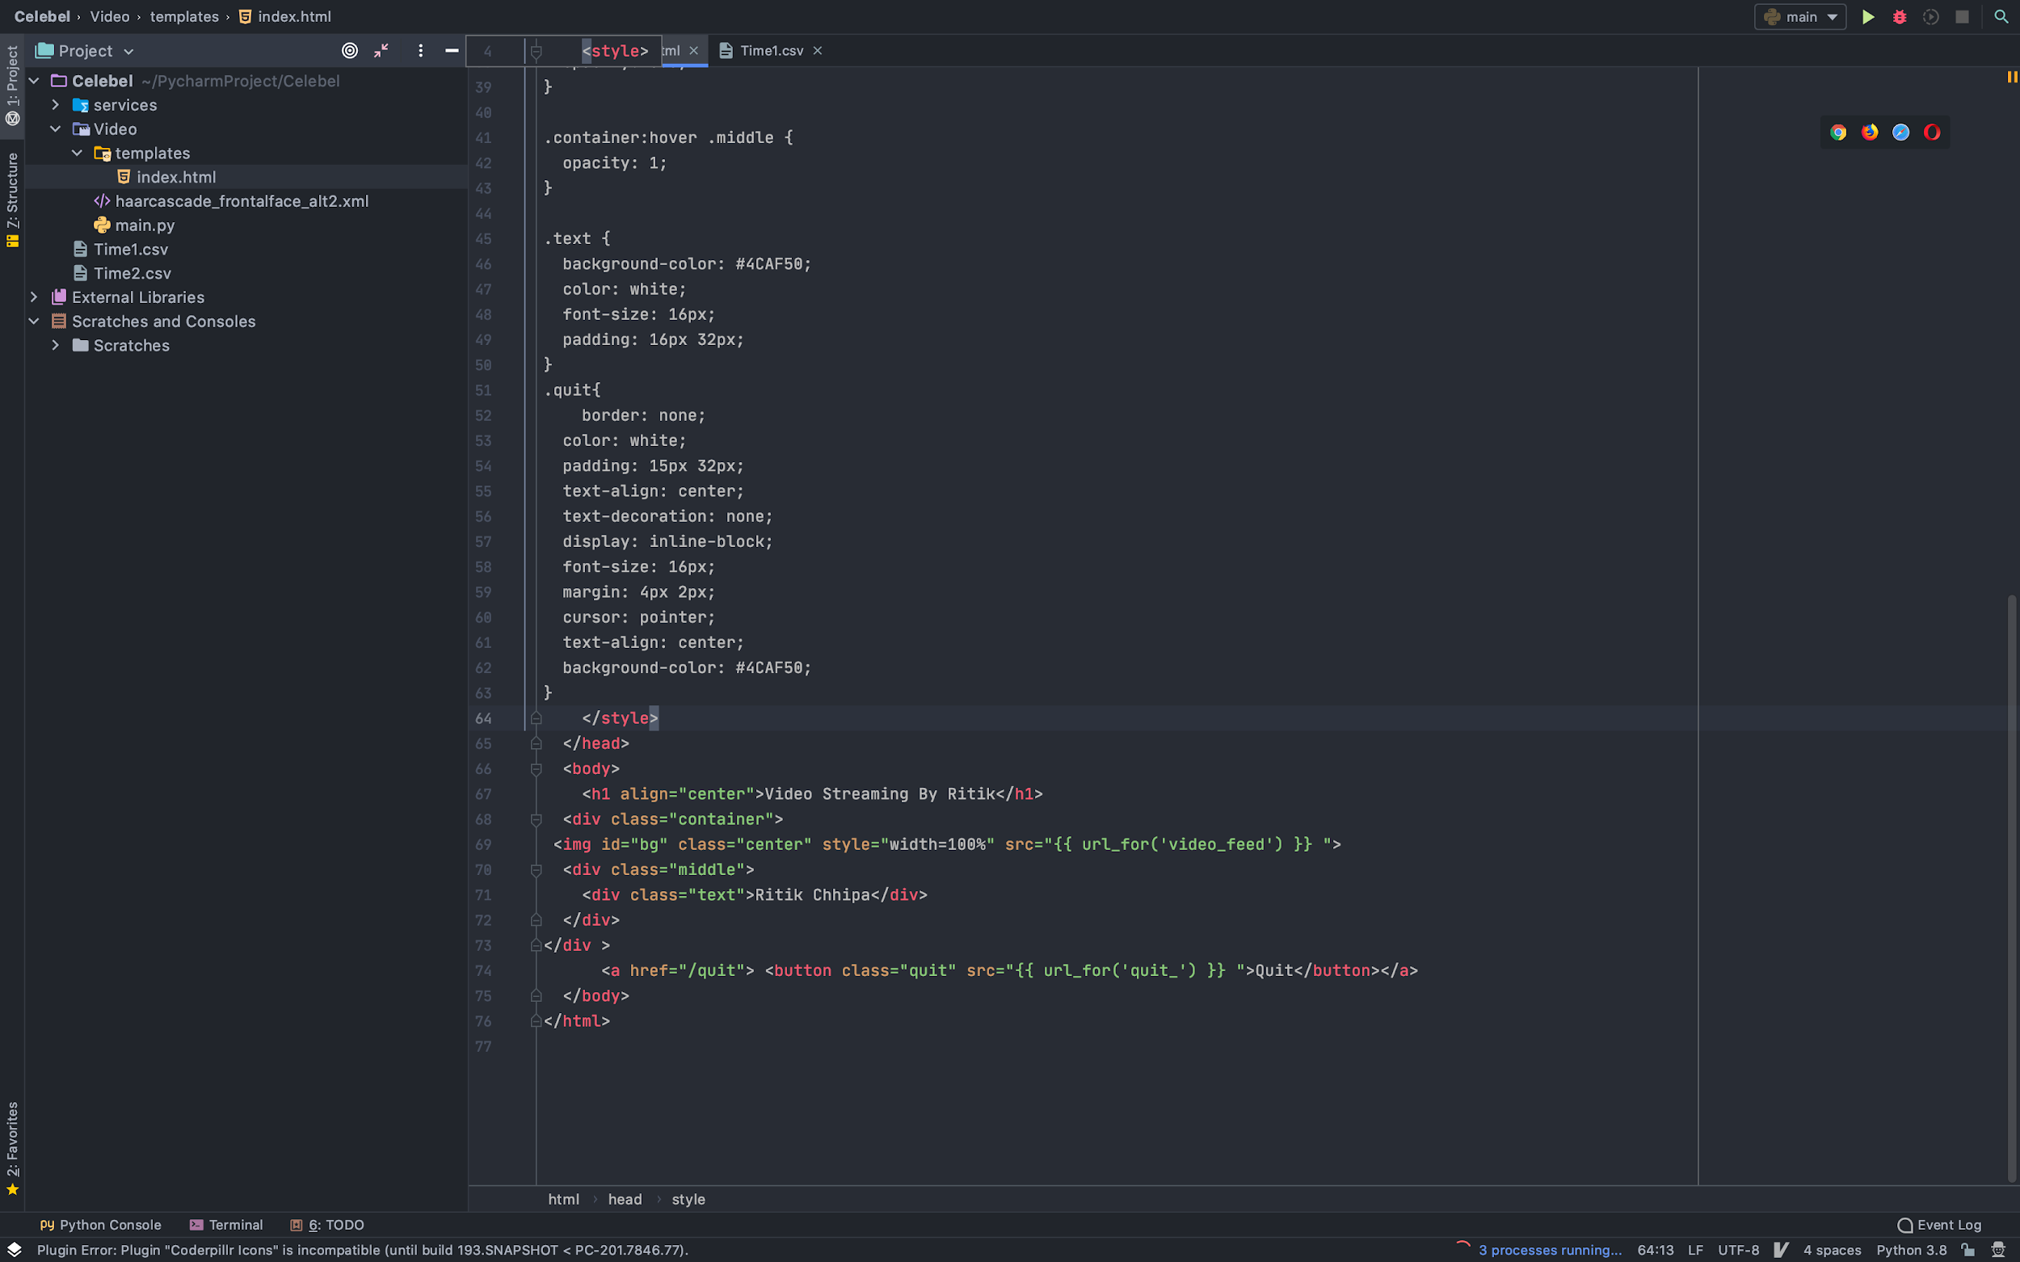

1. Run Task on Local server:

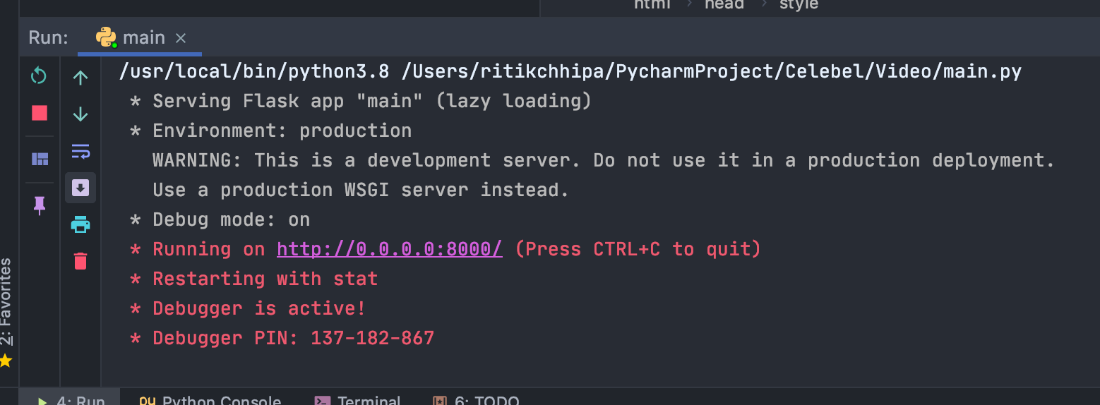

**Preview:-**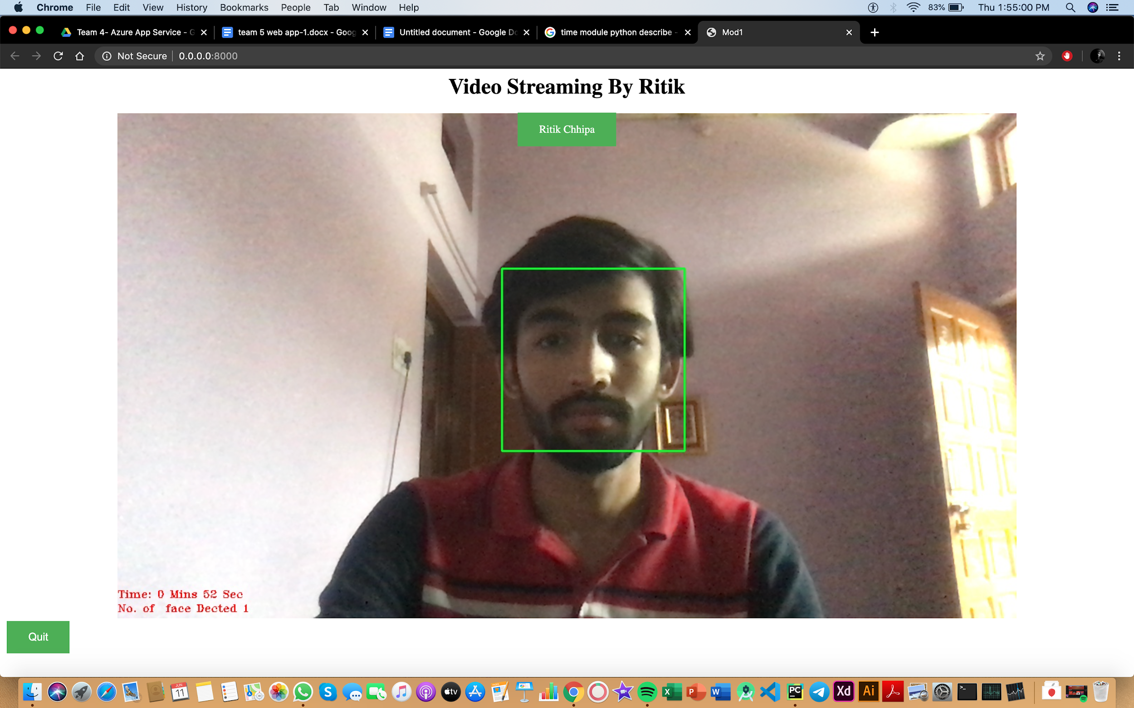

**Reference:-**

[**www.github.com**](http://www.github.com)

[**www.wikkipedia.com**](http://www.wikkipedia.com)

[**www.opencv.com**](http://www.opencv.com)

[**www.python/flask.com**](http://www.python/flask.com)

[**www.pycharm.com**](http://www.pycharm.com)